Standards for sidewalk quality

|  |  |  |  |  |
| --- | --- | --- | --- | --- |
|  | Crack | | | Surface |
| Length | Width | Density |
| Good | Short | Narrow | Low | Smooth |
| Medium | Medium | Medium | Medium | Medium |
| Poor | Long | Wide | High | Rough |
|  | Number of crack pixels / total number of pixels | | |  |

Principles:

Good: There is no obvious crack on the surface, and the surface should be smooth.

Medium: Contains some obvious but no serious damage, or the surface is not smooth, or height difference between two adjacent floor tiles

Poor: have lots of obvious cracks or serious damages.

Good examples

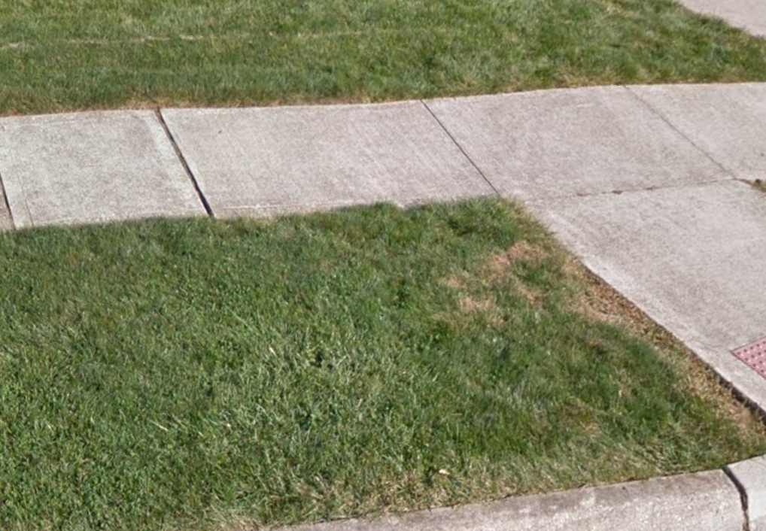 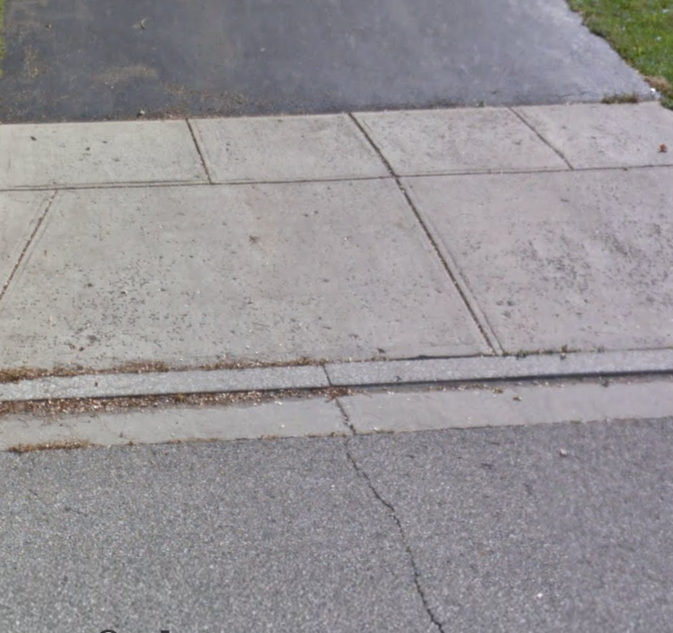 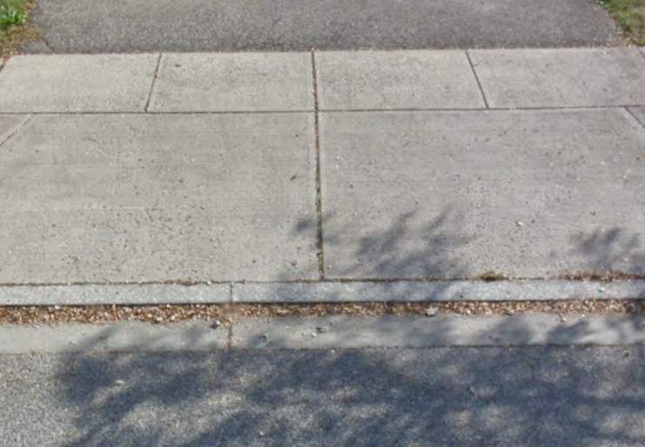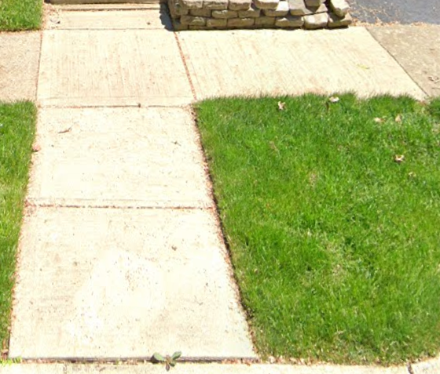

Medium examples

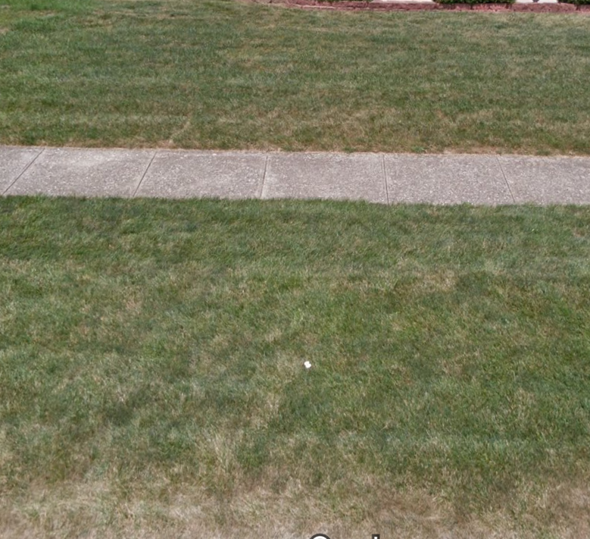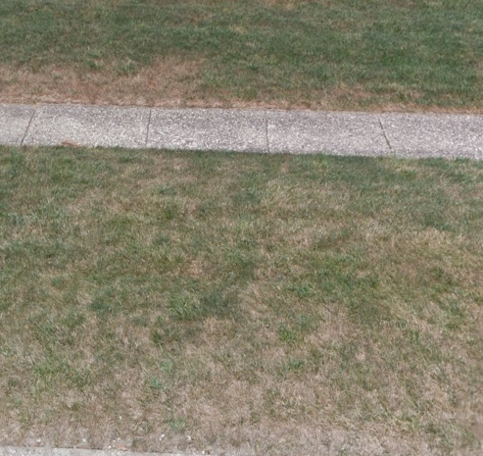

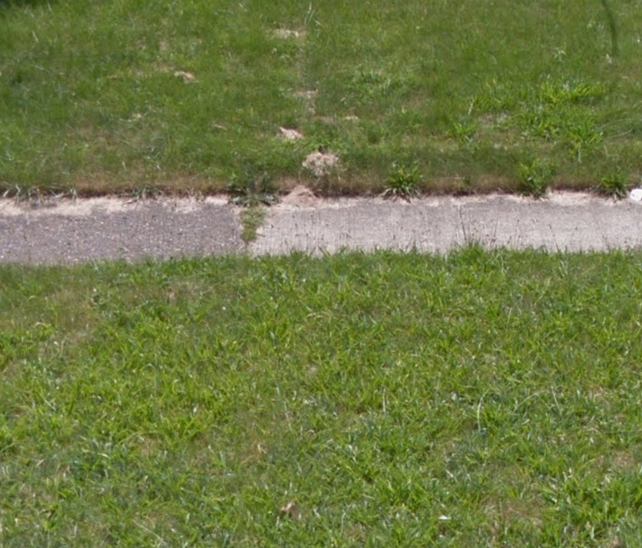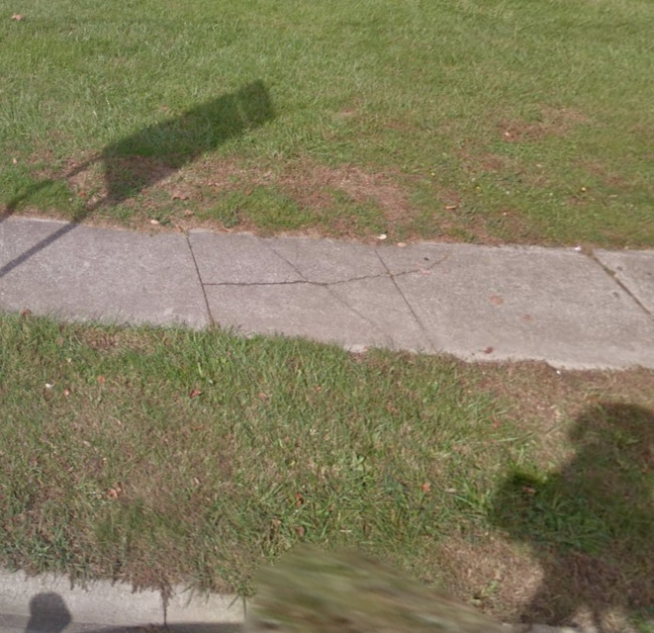

Bad

